ONE KISS Dua Lipa, Calvin Harris
Video: https://www.youtube.com/watch?v=DkeiKbqa02g
Fill in the gaps:
Let me take the night, I love real easy
And I know that you'll still wanna _______ me
On the Sunday morning, music real loud
Let me love you while the _______ is still out
SLEEP
SEE
MOVE
MOON

Something in you, lit up heaven in me
The feeling won't let me _______
'Cause I'm lost in the way you _______, the way you feel
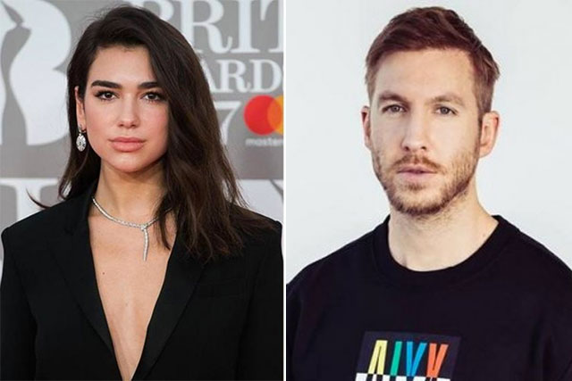
CHORUS Order the lines:
____Fallin' in love with me
____I look like all you need
____One kiss is all it takes
____Possibilities
2x
One One One One

Fill in the gaps:
I just wanna feel your skin on mine
Feel your _______do the exploring
Passion in the message when you smile
Take my _______
SLEEP
EYES
TIME
MOVE

Something in you lit up heaven in me
The feeling won't let me _______
'Cause I'm lost in the way you _______, the way you feel
CHORUS Order the lines:
One kiss is all it takes
Fallin' in…

