DAILY ROUTINE – Present Simple
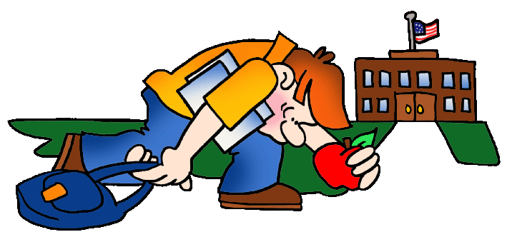
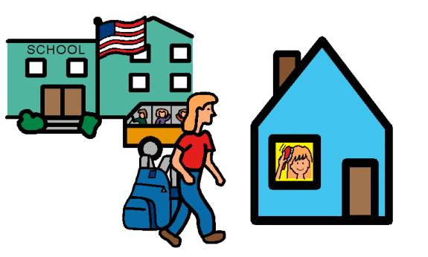
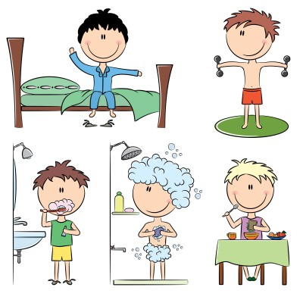
Match the pictures:
HAVE BREAKFAST
GET UP
GO TO SCHOOL
BRUSH TEETH
GO HOME
TRAIN
HAVE SHOWER
GO TO BED
DO KARATE
111
411
511
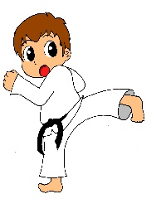
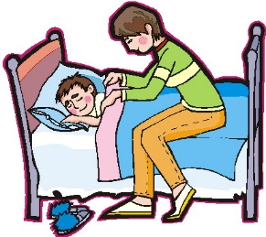

91
211
81
71
61
3

Martin’s day
Martin is a champion in karate. On Tuesdays, Thursdays and Fridays he gets up at half past six, brushes his teeth and goes to the sports centre. He trains with his personal trainer. He wears a karate uniform karategi and yellow belt, he doesn’t wear shoes. He wants to wear black belt one day. Martin finishes his training at quarter to eight and he goes home. At quarter past eight he has a shower and then he has a breakfast. He goes to school at nine o’clock. His school finishes at quarter past two, he has lunch at school at half past two and he goes home at three o’clock. On Mondays he trains in the afternoon at half past five for one hour. He goes to bed at half past eight everyday. On Wednesdays he doesn’t train. On Saturdays he has karate matches. He doesn’t like losing. He usually wins.
Write: YES, HE DOES. or NO, HE DOESN’T.
- Does Martin get at half past six on Mondays? ______________________________
- Does Martin go to the sports centre on Thursdays? __________________________
- Does he train with his trainer? ______________________________
- Does he wear a black belt? ______________________________
- Does he wear shoes? ______________________________
- Does he have a lunch at school? ______________________________
- Does he train on Wednesday afternoons? ______________________________
- Does he like winning? ______________________________
Write the times:
- What time does he brush his teeth? ______________________________
- What time does he finishes training on Fridays? ______________________________
- What time does he go to school? ______________________________
- What time does he have lunch? ______________________________
- What time does he go to bed? ______________________________

