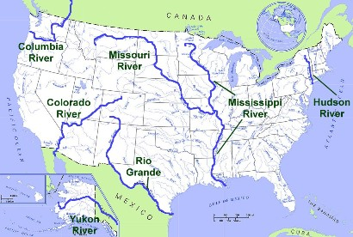
Mississippi
The Mississippi River is one of the most important rivers in the United States. It flows 2,340 miles north to south from Minnesota to the Gulf of Mexico in Louisiana. Together with the Missouri River, it forms the fourth largest river system in the world. The source of the Mississippi is Lake Itasca in Minnesota.
Missouri
The Missouri River is the longest river in the United States at 2,540 miles long. It begins in Western Montana and flows to the Mississippi River just north of St. Louis.
The first explorers who travelled the entire length of the Missouri River were Lewis and Clark.
Rio Grande
The Rio Grande flows 1,900 miles from Colorado to the Gulf of Mexico. Along the way it travels through New Mexico and serves as the southern border of Texas between the United States and Mexico.
Hudson
The Hudson River flows 315 miles north to south in eastern New York. It is a quite short river when compared to many of the other rivers on this page. However, the Hudson played an important role in the early history of the United States. When the Erie Canal was opened in 1825, the Hudson was connected to the Great Lakes. This created a trade route from the Atlantic Ocean to the Great Lakes region
Colorado
The Colorado River flows 1,450 miles from the Rocky Mountains of Colorado to the Gulf of California. The river is famous for carving out the Grand Canyon over the course of millions of years. The Hoover Dam was built on the Colorado in 1936. It provides power to the city of Las Vegas.
Columbia
The largest river in the northwest region of the United States is the Columbia River. It stretches 1,240 miles from the Canadian Rockies to the Pacific Ocean. The river is an excellent source of power and is home to Grand Coulee Dam, the largest power producing dam in the United States.
Yukon
The Yukon River is the third longest river in the United States at 1,980 miles. It begins at Llewellyn Glacier in Canada and flows north to Alaska where it proceeds to travel west across the state to the Bering Sea.

Answer:

What is the longest river in the US?
________________________________________________________
Which river provides electricity to Las Vegas?
________________________________________________________
Which rivers form the fourth largest river system in the world?
________________________________________________________
Which is the shortest river on this page?
________________________________________________________
Which rivers start in Canada?
________________________________________________________
Which river crosses the Grand Canyon?
________________________________________________________

