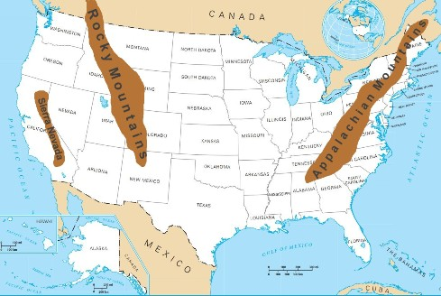

Appalachian Mountains
The Appalachian Mountains run for 1,500 miles along the east coast of the United States from northern Alabama to Maine. The highest point of the Appalachians is 6,684 feet at Mount Mitchell in North Carolina. The Appalachians are mostly covered with a variety of trees including pine trees, spruce, birch, and maple trees. Animals that can be found in the Appalachians include squirrels, cottontail rabbits, white-tailed deer, wolves, beavers, black bears, and the red-tailed hawk.
Rocky Mountains
The Rocky Mountains form the longest mountain range in North America and the second longest range in the world. They stretch 3,000 miles north-to-south from New Mexico, across the United States to Montana, and into Canada. The highest point of the Rockies is Mount Elbert in Colorado which rises 14,440 feet above sea level.
The Rockies are known for their distinct seasons with warm, rainy summers and cold snowy winters. Much of the Rocky Mountains is covered with forests of spruces trees, pines, oaks, junipers, and firs. A wide variety of wildlife can be found in the Rockies including bighorn sheep, badgers, grizzly bears, black bears, coyotes, elk, bighorn sheep, and white-tailed deer.
Sierra Nevada
The Sierra Nevada Mountain Range runs north-to-south along the west coast of the United States. It is around 400 miles long and 70 miles wide. The highest point in the Sierra Nevada Mountains is Mount Whitney at 14,505 feet.
The largest trees in the world, the giant sequoia trees, grow in the Sierra Nevada. They can grow up to 270 feet tall and over 25 feet in diameter. Some of these trees are believed to be over 3,000 years old.

Answer:

What is the longest mountain range in the US?
________________________________________________________
How long is the Sierra Nevada range?
________________________________________________________
Describe the winters in the Rockies?
________________________________________________________
Where can you find the largest trees in the world?
________________________________________________________
What is the highest mountain of Appalachians?
________________________________________________________
Which mountain range is the longest in the USA?
________________________________________________________

